* Julie Lowe*

at

East Bay Trinity Chinese Church

7:30pm, Friday June 29th, 2018.
Venue: San Ramon Presbyterian Church, 12943 Alcosta Blvd., San Ramon, CA 94583
________________________________________________________

Johannes Brahms: Scherzo Op. 4

“Intro to the Journey”

Johann Sebastian Bach: c minor Prelude and Fugue BWV 847, C Major Prelude and Fugue BWV 846

“A Constant through the Twists and Turns with the Ultimate GPS”

Felix Mendelssohn: Variations Serieuses Op. 54

Claude Debussy: Suite Pour le Piano (Prelude, Sarabande, Toccata)

Frederic Chopin: c# minor Nocturne Number 20 Opus Posthumous

“The Greatest Journey to the Greatest Destination”

Ludwig van Beethoven: Rondo a Capriccio - “Rage Over the Lost Penny” Op. 129

“Closing Invitation”

* * * * * * *
Since her American debut with the Seattle Symphony at 17 as winner of the Seattle Young Artists competition, Julie Lowe has performed in numerous solo and chamber music concerts in Albania, Austria, Belgium, Canada, England, France, Germany, Greece, Japan, Spain and the United States and has made solo recordings for the Canadian Broadcasting Corporation (CBC) and West German Radio (WDR).

From 2014, Julie has partnered with Hope2Offer Ministries Canada to combine her spiritual and musical backgrounds in a unique ministry, whereby she parallels the trials which she has gone through with those of many classical composers. Encouraging the audience to reflect on their own life events, she brings them to consider what difference a relationship with Jesus Christ could make in their lives as He has made in hers. These testimony concert mission trips have taken her from the tsunami devastated areas of Japan to her musical roots in Germany, from her hometown in Canada to favourite cities in the US. Plans for 2018 include Northern California, Paris and Vienna.

For more information and videos, please visit julielowe.com or facebook.com/julielowepiano
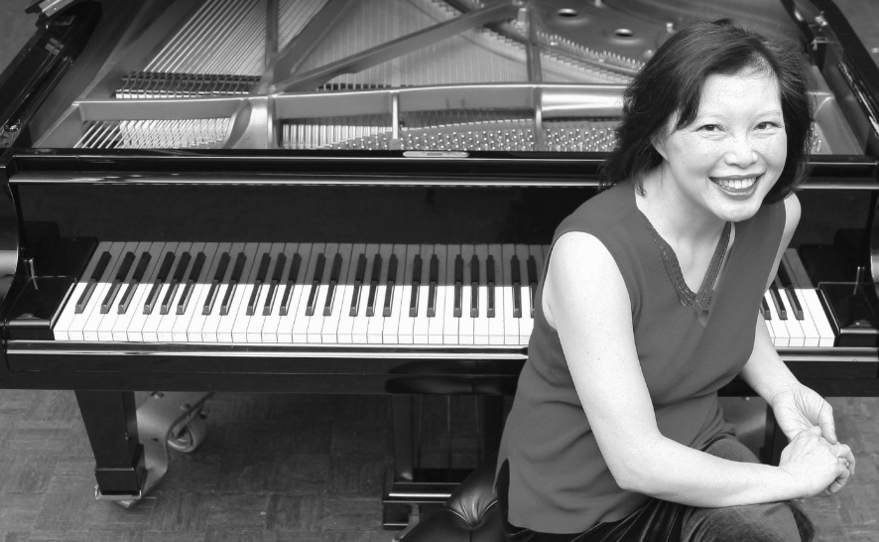
Julie appears on this concert tour courtesy of Hope2Offer Ministries Canada. If you have been blessed and would like to support her work, please consider making a tax deductible contribution towards this ministry:

By credit card online through: julielowe.com/support

By check mailed to: International Christian Mission Services: PO Box 8000 PMB 698, Sumas, WA 98295.

Please write “For Julie Lowe Hope2Offer Ministries” on the subject line.

All donations received in the United States will be receipted for the Internal Revenue Service by ICMS. Thank you so much and may God bless you very deeply!

